Single Cycle CPU Diagram:

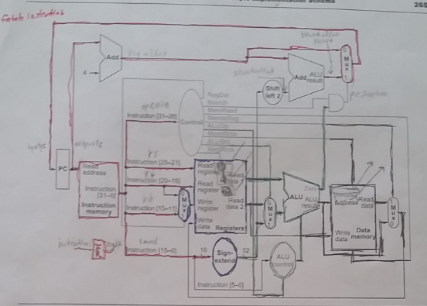

Instruction fetch unit: highlighted in red

Register fetch unit: highlighted in blue

ALU operation unit: highlighted in green

Data fetch unit: highlighted in black

CPU Controller: non highlighted portion